Name ___________________________________

R110

G-Clamp Project

Internal thread cutting, round bar

Centre Lathe Machining

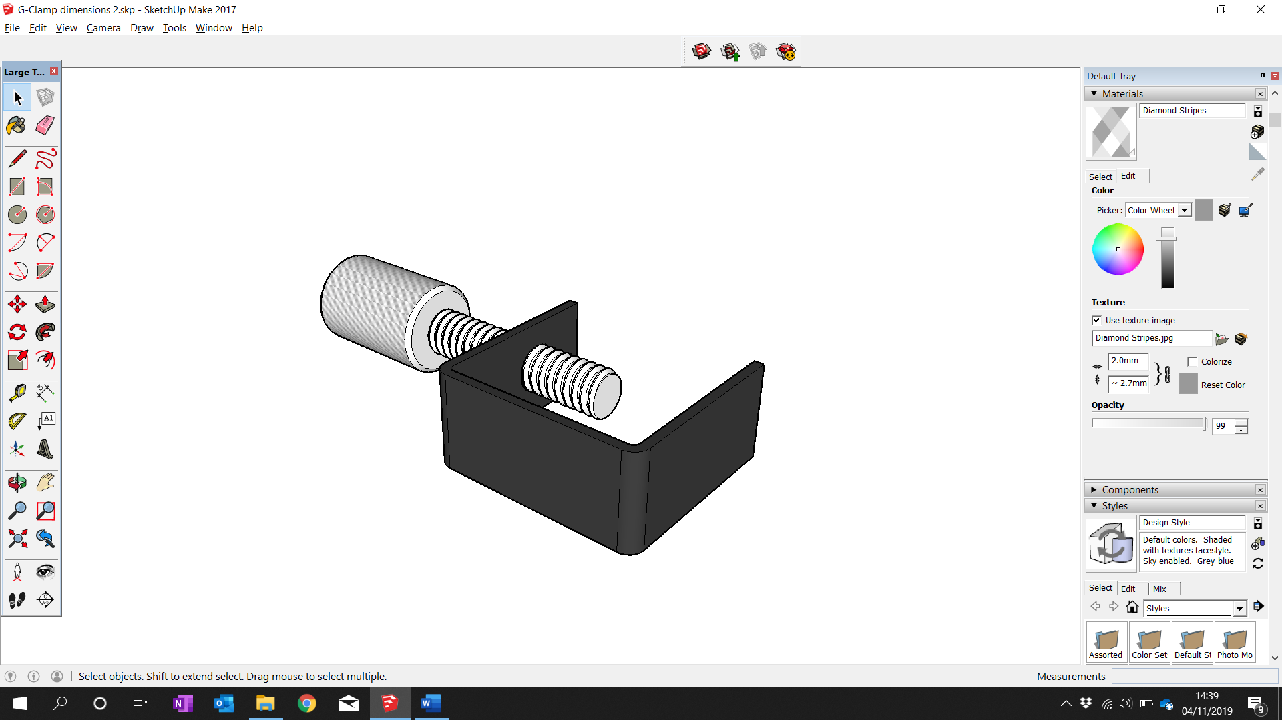

Internal thread cutting, flat bar

Plastic Dip Coating

Forging

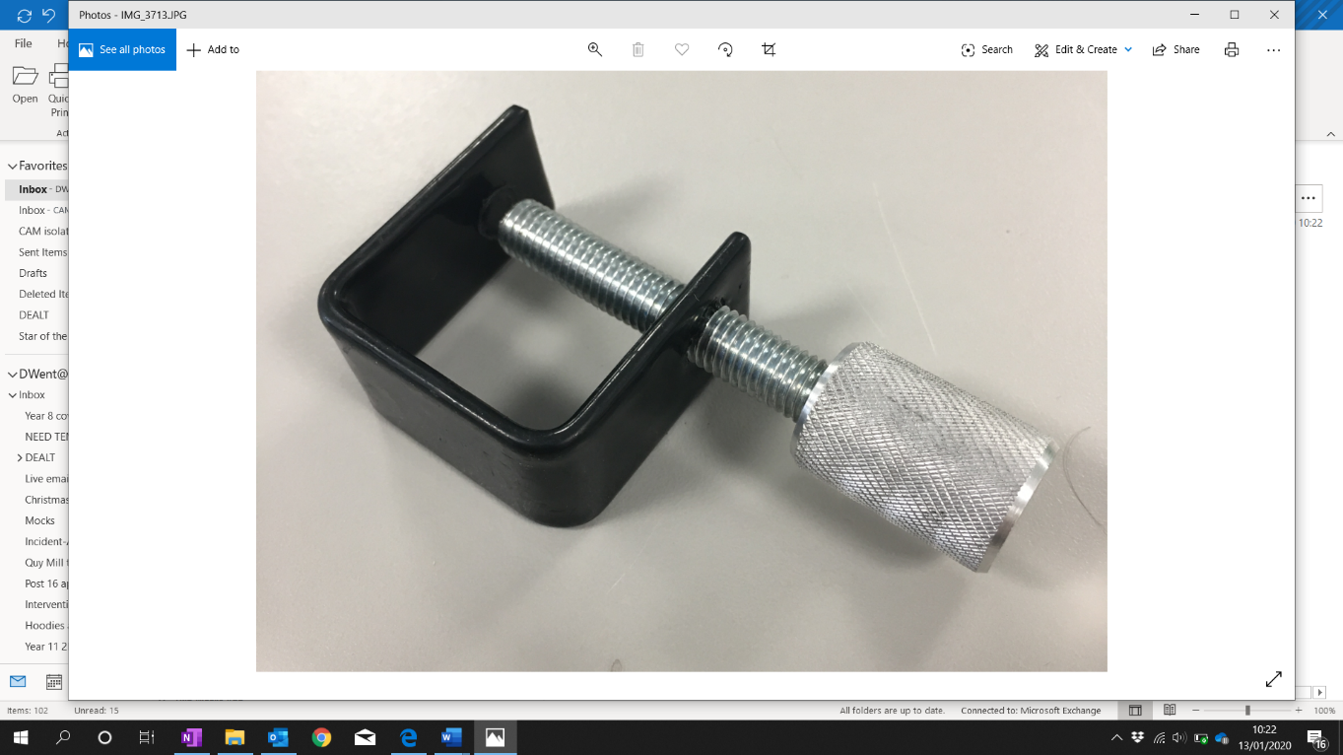

Preparation Tasks

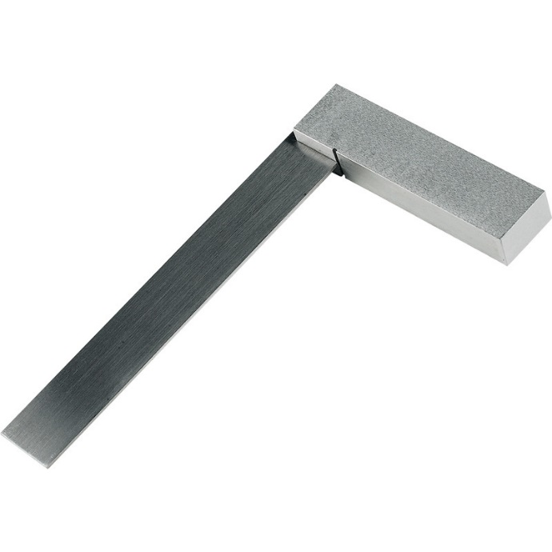

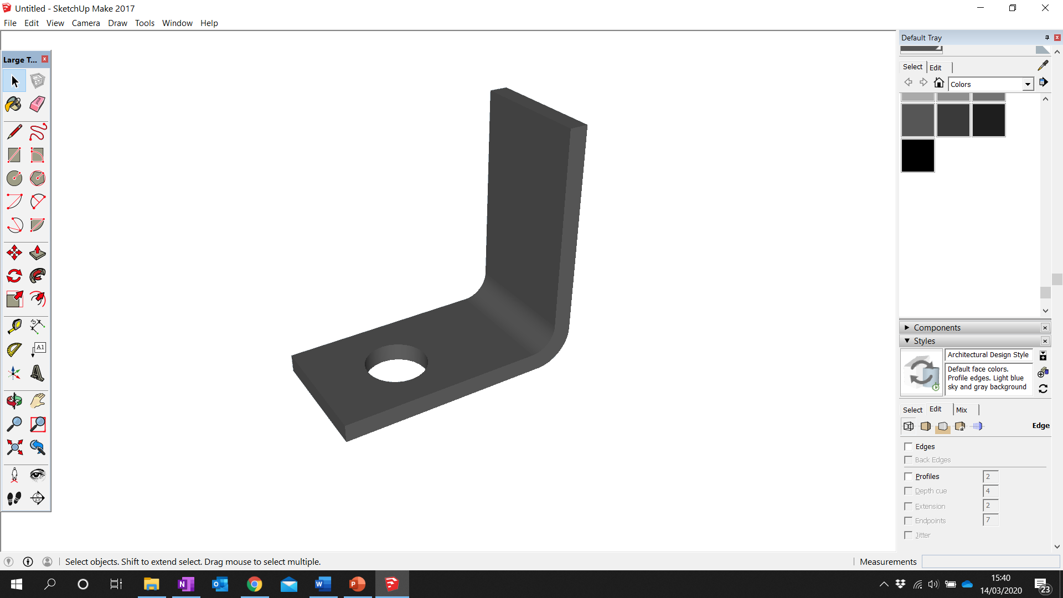

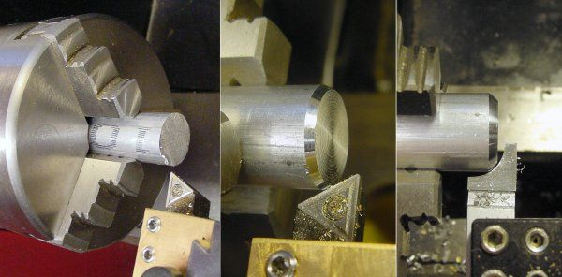

**Using a Micrometer**

|  |  |
| --- | --- |
| Demo watched |  |
| Student practised |  |

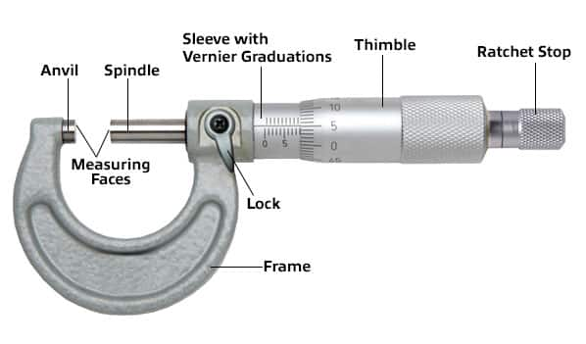

**Using Digital Calipers**

|  |  |
| --- | --- |
| Demo watched |  |
| Student practised |  |

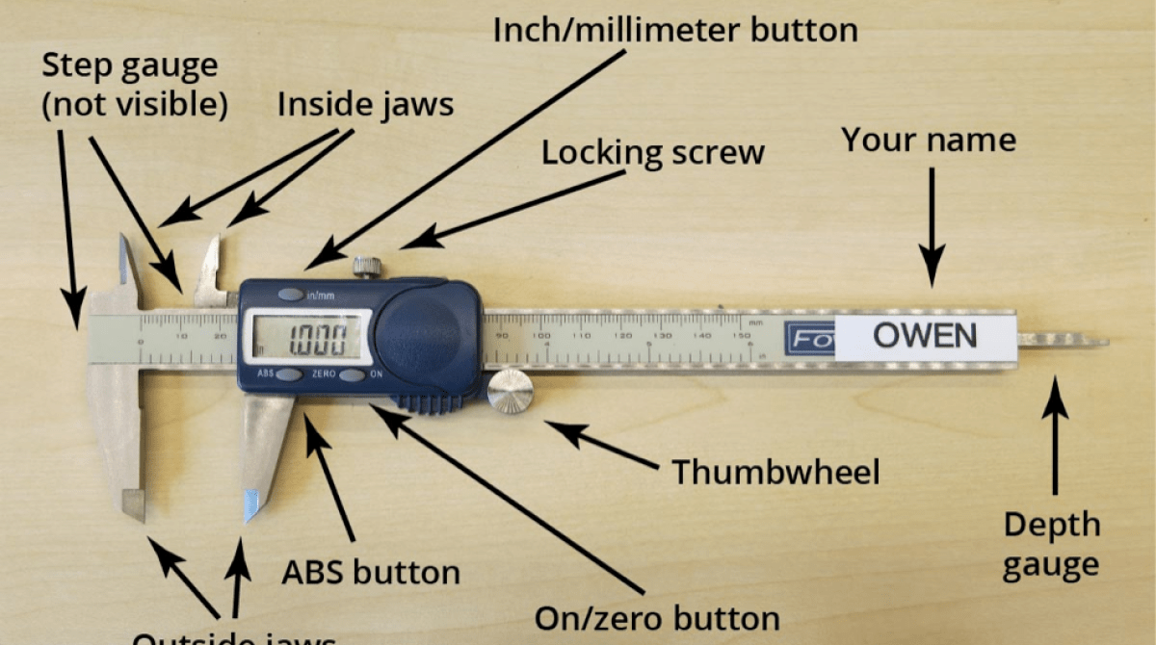

**Drilling**

|  |  |
| --- | --- |
| Demo / Video watched |  |
| Health & Safety understood |  |
| Health & Safety agreed |  |
| Student practised |  |

Staff notes/signature

**Internal thread cutting (flat bar)**

|  |  |
| --- | --- |
| Demo / Video watched |  |
| Health & Safety understood |  |
| Health & Safety agreed |  |
| Student practised |  |

Staff notes/signature

**Forging**

|  |  |
| --- | --- |
| Demo / Video watched |  |
| Health & Safety understood |  |
| Health & Safety agreed |  |
| Student practised |  |

Staff notes/signature

**Plastic Dip Coating**

|  |  |
| --- | --- |
| Demo / Video watched |  |
| Health & Safety understood |  |
| Health & Safety agreed |  |
| Student practised |  |

Staff notes/signature

**Centre Lathe – facing off**

|  |  |
| --- | --- |
| Demo / Video watched |  |
| Health & Safety understood |  |
| Health & Safety agreed |  |
| Student practised |  |

Staff notes/signature

**Centre Lathe – Centre Drilling**

|  |  |
| --- | --- |
| Demo / Video watched |  |
| Health & Safety understood |  |
| Health & Safety agreed |  |
| Student practised |  |

Staff notes/signature

Let’s begin Controlled Assessment

No helping each other. Only support from Teacher / TA

Your assessed tasks

1. Manufactured G-Clamp (steps photographed)
2. Dimension drawing, annotated and explained
3. Plan of Manufacture
4. Modified Plan for Batch Production
5. Evaluation of G-Clamp & manufacture

Pattern of Working

1. Study and understand **Dimension drawing**
2. Add some annotations to **Dimension drawing**
3. Complete a manufacturing step in the workshop. Photograph
4. Write up step into to **Plan of Manufacture**. Insert photographs
5. Repeat from Step 2 until G-Clamp and Plan are complete
6. Complete **Evaluation of G-Clamp & manufacture**
7. Research and complete **Modified Plan for Batch Production**

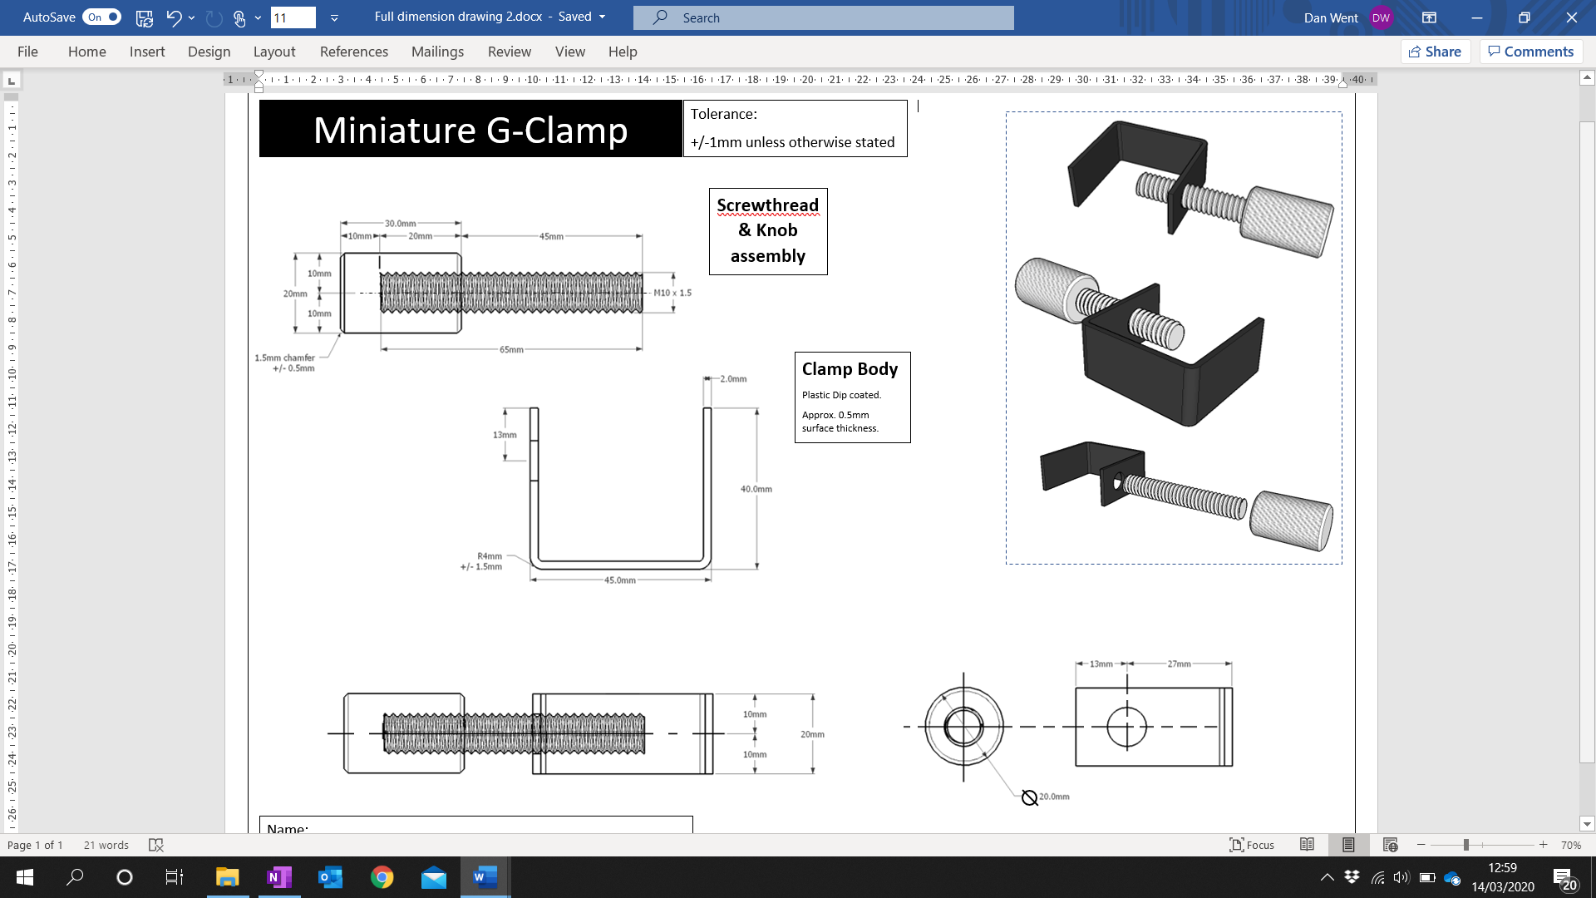

Dimension Drawing

TASK

1. Study every aspect, every part, every dimension.
2. Label the parts of the G-Clamp
3. Annotate both the 2D drawings and 3D drawings

**Accessing highest marks**

Labels + annotations on both 2D and 3D diagrams

These points need to be covered comprehensively on the diagram. For example, have you explained how you’ll make each part? Have you shown interpretation of the dimensions?

Make sure you show you fully understand the drawing conventions – **Point 6.** (e.g. which lines are not part of the G-Clamp but for the purposes of the diagram?

1. Annotate, showing how you will manufacture each part of the G-Clamp
2. Annotate the materials
3. Annotate, showing what the drawing symbols and conventions mean
   * The Radius and Diameter symbols
   * The meaning of the tolerance statements
   * Which view is which, and why are these views necessary?
   * Diagram lines and G-Clamp edges?
   * Explain what the dimensions mean / relate to
4. Annotate anything else you notice

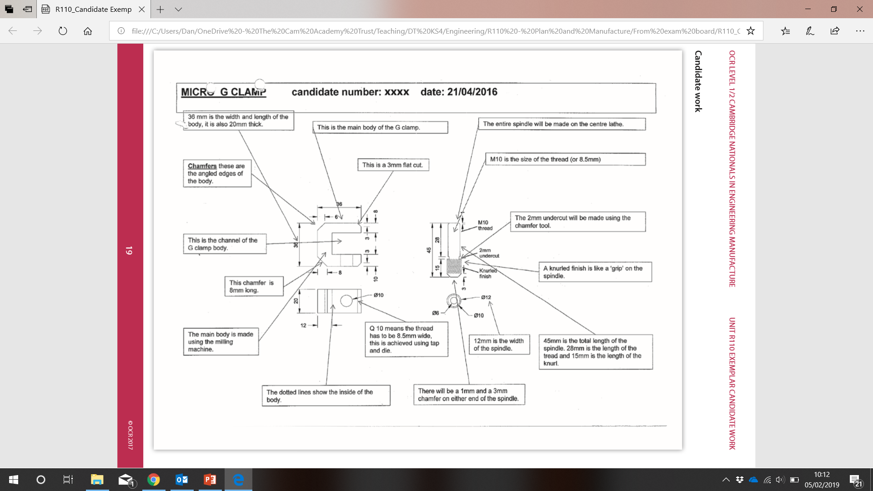Example:

Making the G-Clamp

Your Queue position for Lathe:

Important reminders

* Don’t forget all your safety steps/PPE.  
  **No PPE = no practical**
* Don’t forget to get **photos** of each stage
* Don’t forget to use **Quality Control tools**  
  to check measurements (and photograph you using them)
* Don’t forget to neatly **update any annotations** on your Dimension Drawing
* Don’t forget to **add the steps to your Plan** as you go

Production Plan

Create a Production Plan, explaining how to make the G-Clamp, step by step.

Your production plan should include sufficient detail so that if someone had your plan, they could follow it and safely manufacture the G-Clamp successfully and accurately, with minimal extra help.

**Accessing highest marks**

Customise the table. Try adding a column, or reorganising the columns, linking to your manufacturing knowledge and the requirements of the mark scheme.

Ensure you describe steps in detail. For example, how do you adjust the tool before use? What is the work held in? What measurement are you cutting?

In Health and Safety, have you covered everything off? Avoid lots of copy-pasting! Have you mentioned how to check if the hand tools are safe / undamaged before use?

Add specific references to where your knowledge links with other units. E.g. “I learnt about how to use Digital Calipers in R112 Quality Control.” or “This knowledge links with theory learnt in R109 – topic ‘Quality Control Checks’”

Are your timings realistic? You could add some justification to why you estimate some of the timings

Create a table. It should include the following columns:

* The step (with description)
* Health and Safety
* Quality Control

It should also include

* Tools, machines, equipment required
* Timing

Then, insert the steps into the plan **in suitable sequential order**. That means in the correct order for manufacturing to be successful

Photographic Evidence of Making

What do I need photos of?

You need to have photos of you making your G-Clamp.

It doesn’t need your face in it from the front, but in most photos, there ideally needs to be **enough of the side of your face** to identify it as you.

Where do they go?

You could include these in your Production Plan, but most people put them into a separate section of their Student Work Document.

How many photos should I have?

Probably about 14-16.

You need **photos of key stages**. For example, on the Lathe at least 6 photos:

* At least 1 of setting up lathe
* Facing off
* Chamfering
* Drilling
* Other turning processes
* At least 1 of you checking measurements afterwards with QC tools
* Example – about 5/7 photos of the lathe steps
* Annotate your photos…

What about Annotations?

You **must annotate each photo** to explain what you’re doing.

Example: *"here I am facing off, I'm wearing an apron and…"*

You could also mention the PPE you’re wearing and safety procedures you’ve followed too. This is good evidence.

Evaluation of Manufacture & Photos

Place 2 clear photos of your G-Clamp onto page **’Final G-Clamp Photographs’**

Produce an Evaluation of the quality of the G-Clamp.

Compare the G-Clamp with the Dimension Drawing. How does it compare?

**You should:** Make use of appropriate Quality Control checks/tools.

1. Shape
2. Measurements
3. Angles
4. Finishes

**Accessing highest marks**

You could include photos of you carrying out these checks, with the correct measurement checking tools.

**Also**, synoptic links…

Explicit, clear, specific, several

Add references to other units (R109, R111, R112) where you used knowledge from these in your work on R110

*"I learnt how to use this tool in R112, when working with…"*

1. Function

This might be best as a table with appropriate column headings?

**You could:** include columns which show and compare the required dimensions (and tolerance ranges) with the actual dimensions of your G-Clamp

|  |  |  |  |  |
| --- | --- | --- | --- | --- |
| **Measurement on drawing** | **Checking tool** | **Expected measurement** | **Actual measurement** | **Comment** |
|  |  |  |  |  |
|  |  |  |  |  |

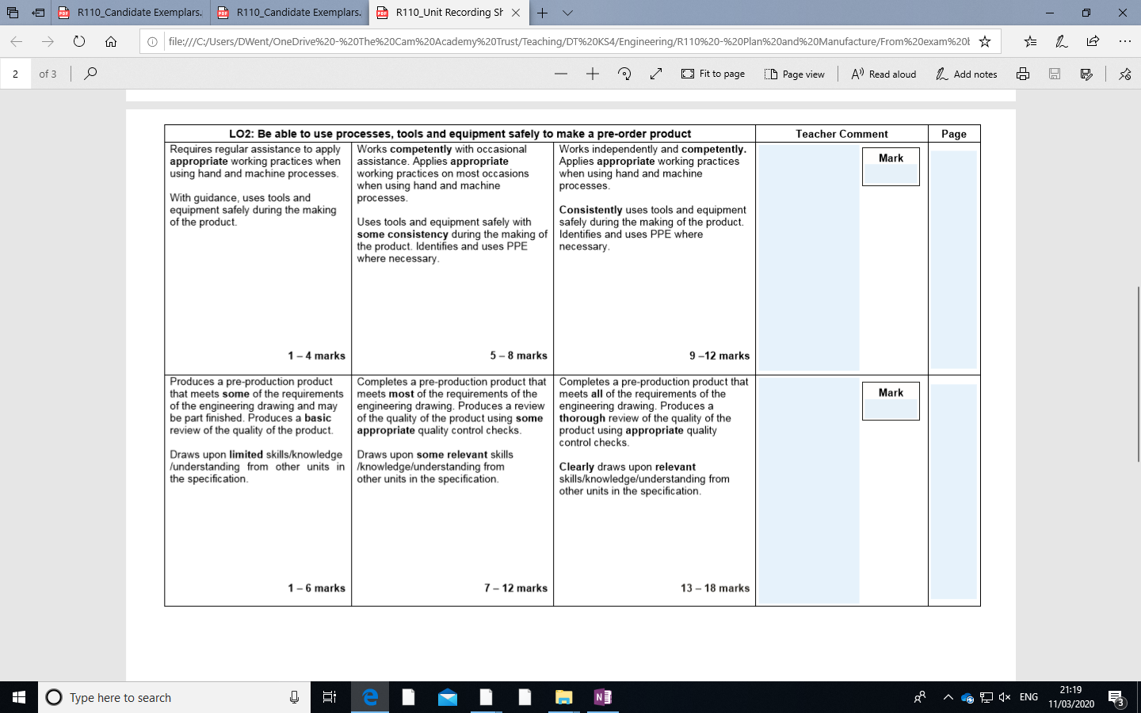

*“Produces a thorough review of the quality of the product using appropriate quality control checks”*

Production Plan for batch of 1000

The manufacturer has reviewed your G-Glamp and has given approval for production. The next production run will be for a quantity of 1000. You need to consider the impact on the planning and processes used for manufacture.

**Task:** Produce a modified plan suitable for the specified quantity production of the product. Start with your original Production Plan.

**You must include:**

* Correctly sequenced batch production steps for manufacturing a batch of 1000 G-Clamps, instead of just 1.
* Special batch production techniques with descriptions, for example:
  + Using standard material (stock) size, jigs, templates, end stops
  + Using the same machine, but set up for performing repeated and accurate operations
  + Using specialist manually operated machinery to complete processes more quickly and efficiently
* Tools and machines with description

**You should include:**

* Refer to **specific measurements** in the steps (they are all on the diagram, remember)
* Modified accurate **Timings** for each step
* appropriate changes **Quality Control steps** to ensure consistent, high quality of the final products
* specific appropriate **Health and Safety** advice for each step

**You could include:**

**Accessing highest marks**

Be really detailed in how the machinery would be set up to be most accurate and efficient

Suggested further **modifications**.

Your timings could be **justified**.

Your plan could be prefaced with some information on **different scales of production** (one-off, batch, mass).

You could add a column “**Mass Production**” which details appropriate changes which could be made to mass produce the part/step.

* **Layout of production line**
* **Suggested staffing requirements**
* **CNC machines.** If you do, only do so as an alternative to a manual method, and/or clearly justify their use. If there are suitable manual methods, these should be used. In other words, it’s not OK to just say “get a CNC machine to cut out the”... whatever