Name ___________________________________

R111

Computer Aided Manufacturing

G-Clamp Go-no-go Gauge

(for Quality Control)

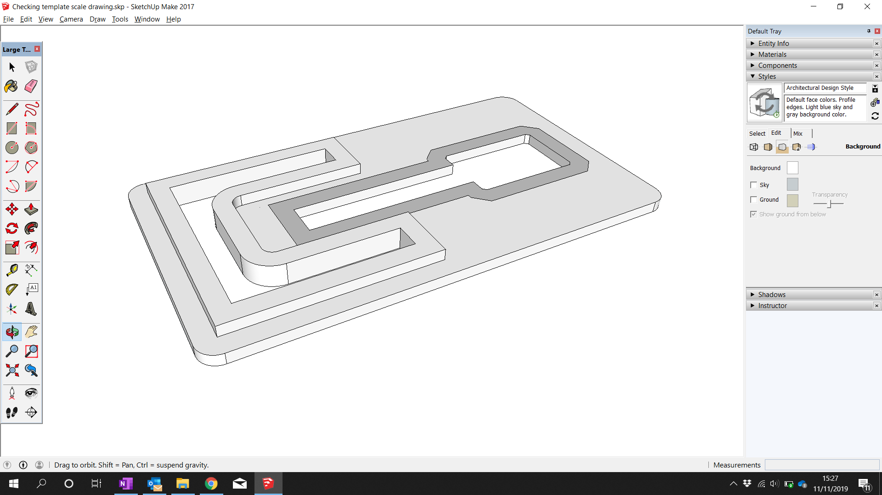

2D Design learning

1. 60 
   40 
   R37 
   R25 
   39 
   R24 Drawing 2D Shapes
2. 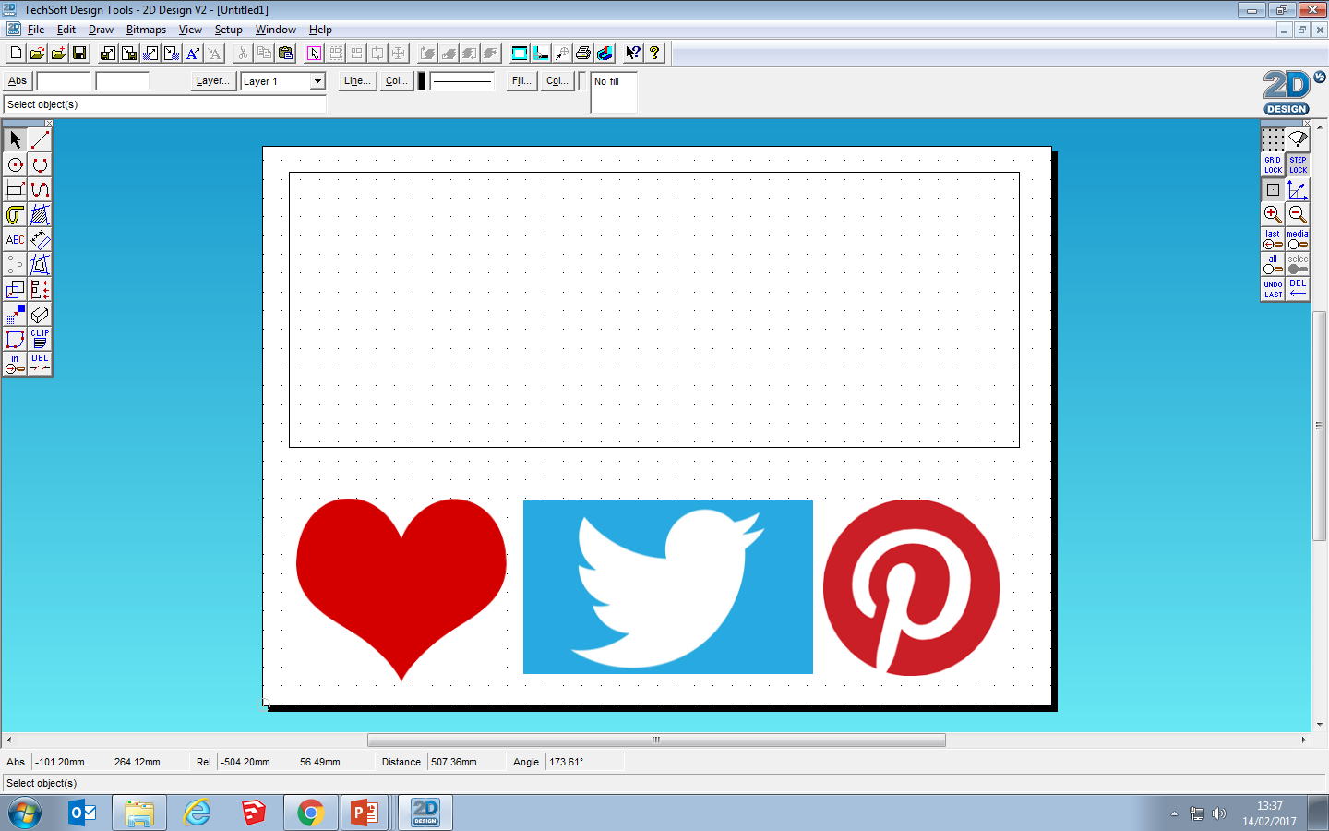Tracing shapes

Keyfob Laser Cutting Demo & notes

Laser Cutting notes (these are important – make thorough notes):

|  |
| --- |
| 2D Design settings |
| Safety and Machine Checks |
| Machine Setup and operation |

Produce your own Acrylic Keyfob

Acrylic Keyfob (60 x 60mm limit).

Use at least 2 depths (cutting/engraving)

Batch produce 2.

A close up of text on a white background

Description generated with very high confidenceHex 2D Design file

Let’s get started  
G-Clamp Quality Control  
Go-no-go Gauge

The G-Clamp pre-production prototype produced in unit R110 has been approved for manufacture. As part of the Quality Control procedures on the production line, a **Go-no-go Gauge** is to be produced for use by workers on the production line. It will be used to ensure that the G-Clamps coming off the production line are within accepted tolerances.



A small batch quantity of five Go-no-go Gauges is to be manufactured using CNC machining.

For this unit, you will need to:

* interpret the engineering drawing provided (later in this booklet)
* produce a CAD drawing of the component to be manufactured suitable for export to the CNC machine
* export drawing information to CNC and perform on-screen simulation of production interpreting and acting upon the information gained
* produce a detailed production plan for the batch manufacture of the Go-no-go Gauge

CNC Production Plan

In order to be successful, the production must be carefully planned. Produce a detailed plan for the batch manufacture of the Go-no-go Gauge.

It must include:

* Steps in the correct order
* Description of how to do each step
* Safety (using laser cutter)

It should include:

* *Tool changes* – different colours in line and fill for different laser operations
* *Material* - setting correct speeds for cutting and engraving etc
* *Tool offsets* - Setting the laser starting point, depth
* *Scale* – how to produce more than one
* *Timing* – How long each step will take

It could include

* *Quality Control* – How you will ensure each step is checked

Example:

G-Clamp Go-no-go Gauge  
Dimension drawing

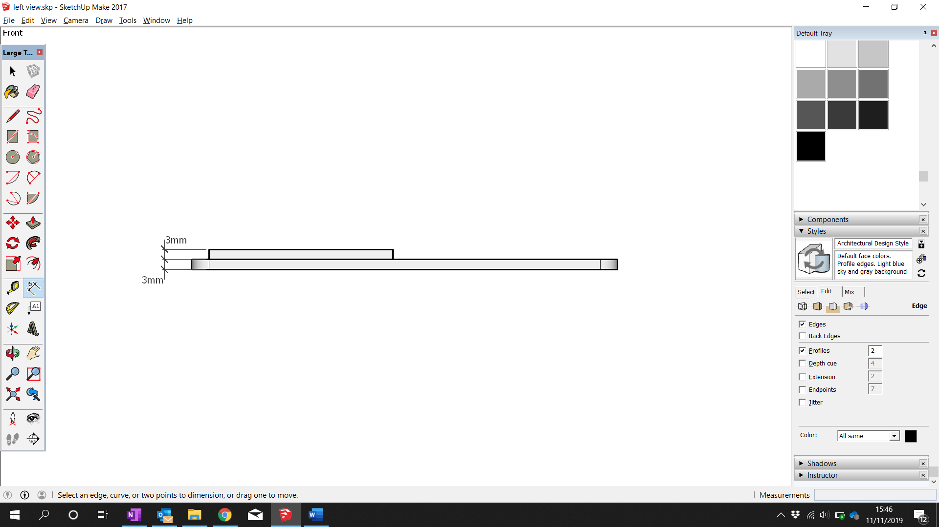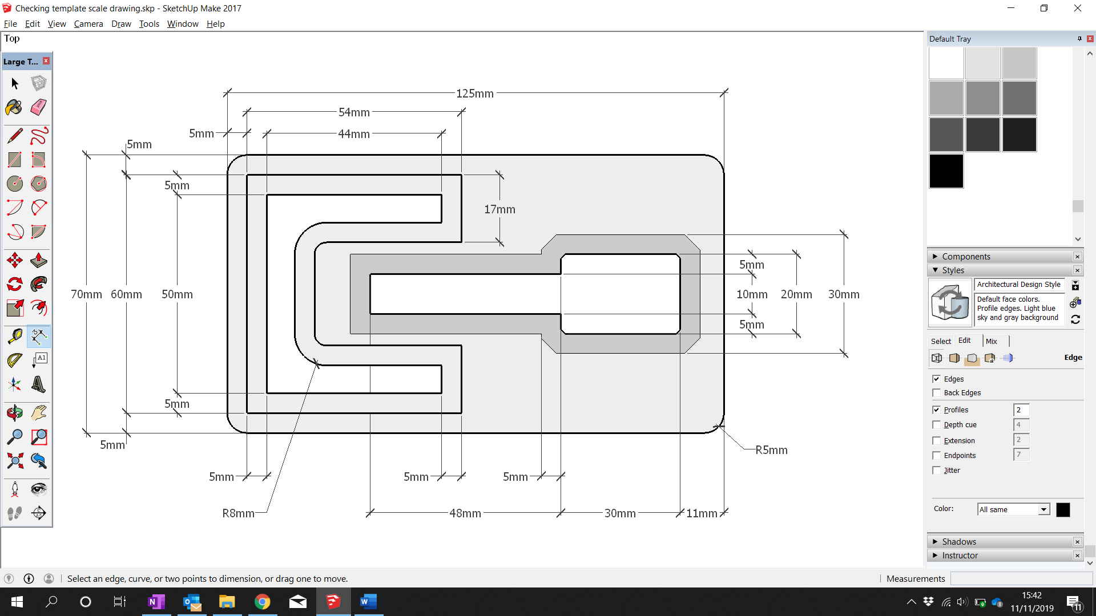

Shaded area denotes engraved area

Annotated Dimension drawing

TASK

* Study every aspect, every part, every dimension.
* Annotate the materials
* Calculate and annotate the measurements that are not explicitly provided on the drawing
* Annotate, showing what cutting operation / speed/power settings might be needed for different parts of the drawing

LO2: Screenshot Evidence

Drawing (2D Design)

Screen shots of you drawing the Go-no-go Gauge

Pasted into your R111 shared document and annotated

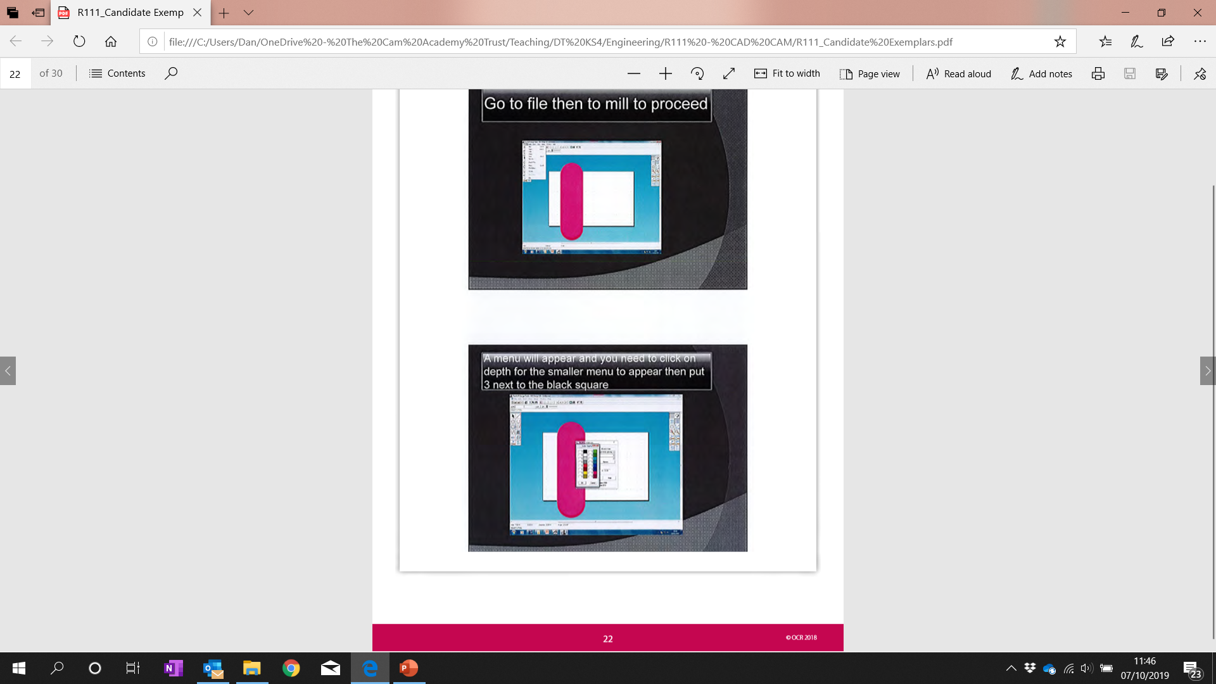Example:

LO2/LO3: Screenshot Evidence   
Settings for Laser Cutting

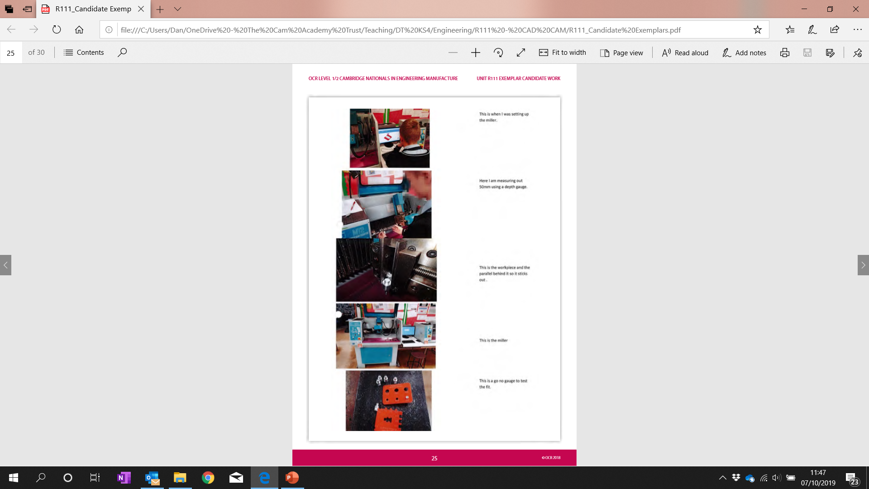

Annotated photos of you operating the  
laser cutter

* Setting up on the laser cutter computer
* Setting up the laser cutter
* Cutting

Example 🡪

LO3: Photo Evidence   
Laser Cutter setup, Simulation, Operation

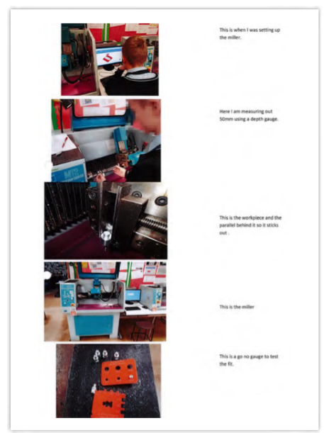

LO3 *optional:* Review of Quality

To access higher marks, review the quality of your finished piece against the Dimension Drawing. An example of how you could do this is here:

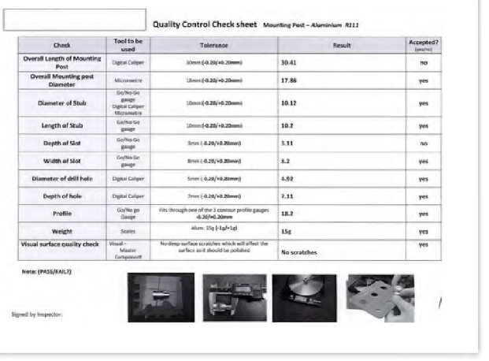

LO3 *optional:* Risk Assessment

**What is a risk assessment?**

‘Risk assessment’ is a term used to describe a process or method where you:

* **Identify hazards** (risks and dangers) that could cause harm
* **Evaluate the level of risk** associated with that hazard (how likely it is to happen and how serious the effect if it did happen).
* **Decide precautions** to reduce the risk of them happening (what can we do to reduce the chances or remove the risk entirely)
* **Record this** for others to refer to and use
* **Review it** in the future

**Your Risk Assessment**

You need to use the laser cutter for this project. Produce a risk assessment for using the laser cutter.

This could be done in a table (decide on suitable headings yourself)

Suggested steps:

1. List the hazards / dangers
2. For each one:
   1. Decide how likely each is to happen (perhaps with a number range?)
   2. Decide how serious each is if it did happen

Record actions to reduce the risk

LO3: Manual vs. CNC Comparison

Manually Made Checker

You will now build a version of the Go-no-go Gauge by hand. Use the dimension drawing, measuring tools and cutting and filing tools.

You will then write a comparison between the laser cut version and this manual version.

Comparison

If you made a batch of the checkers with CNC and by hand, there would be some big differences.

Mention the differences in consistency, cycle time and visual finish

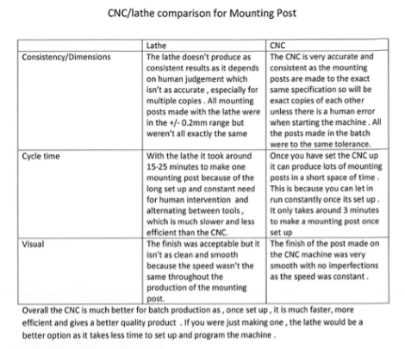

Example:

LO4: Report

You need to produce evidence that shows you know about applications of computer-controlled processes used to manufacture products.

A company wishes to invest in additional computer-controlled equipment in order to improve its manufacturing. The company wishes to be able to work with a range of materials at different scales of production: **one-off/prototype**, **batch** and **high-volume** production.

You have been asked to prepare a report showing different options they could consider investing in.

Consider how rapid prototyping, manufacturing processes and robotics could be used for one-off/prototype, batch and high volume production of a product and its components.

**Your report should include:**

* An outline of computer-controlled processes/CNC machines used in manufacturing
* Information about processes / machines (such as CNC, additive manufacturing, robotics etc)
* A description with examples of computer-controlled processes used for **different scales** of manufacture (one-off/prototype, batch and high-volume production).

**To access high marks:**

Demonstrate knowledge of:

* Types of CNC processes and use of them (with examples)
  + Milling machines, turning centres, fabrication machines
* How different CNC are suited to different production scales (with examples)
  + One off
    - Laminating, 3D printing, stereolithography, laser sintering
  + One off & Batch
    - CNC manufacturing
    - Additive
  + Batch & Mass (high volume)
    - Robotics: welding, riveting, pick and place (fabrication)