Name ___________________________________

R112

Quality Control

|  |  |
| --- | --- |
| Quality in Engineering: Key phrases 1 |  |
| Introduction task: Quality Control |  |
| Quality in Engineering: Key phrases 2 |  |
| Introduction task: Lean Manufacturing |  |
|  | |
| Task 1 (10%): Report (Importance of QC) |  |
| Task 2 (45%): Assessment of Product Quality |  |
| Task 3 (20%): Report (Modern tech. in QC) |  |
| Task 4 (25%): Report (Lean Manufacturing) |  |

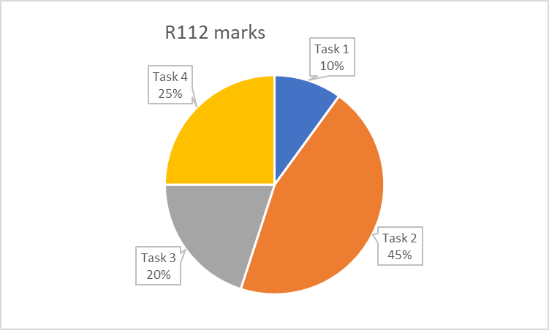

Quality in Engineering: Key phrases 1

There are some phrases associated with Quality Control you need to understand in order to be successful with this unit.

For each phrase, use the videos and use the internet and complete the table below. You can then refer to this as you go through the rest of the unit.

Videos – Youtube tutor2u - Quality Management – Intro, - Quality C.

Youtube – “quality control in engineering”, Mulsanne Quality Control /Inside Bentley, Toyota

|  |  |
| --- | --- |
| **Phrase** | **Definition (with example if you can)** |
| Quality Management |  |
| Quality Control |  |
| Quality Standards |  |

Now complete next task

Introduction task:

Quality Control

To be successful, engineering manufacturers should aim to produce products that are of a consistently high quality for their customers.

**The company that manufactures the G-Clamps (produced in R110) is reviewing its quality control processes and procedures.**

Quality control is an important part of the production process. Quality control is required for the production of the G-Clamp to ensure it consistently meets the design specifications.

**Task:** Research and describe below examples of quality control procedures used by manufacturing companies.

1.

2.

3.

4.

5.

Quality in Engineering: Key phrases 2

Videos – Youtube tutor2u - Quality Assurance, Lean Prod, JIT…

|  |  |
| --- | --- |
| **Phrase** | **Definition (with example if you can)** |
| Quality Assurance |  |
| Lean Manufacturing |  |
| JIT |  |

Categories of Quality Management

There are 5 areas of quality management to focus on. For each, find examples.

Complete the table below

|  |  |  |  |
| --- | --- | --- | --- |
| **Type of Quality Control Procedure** | **What it is...** | **What benefit does it bring?** | **Example(s) of this in production** |
| Early Intercept |  |  |  |
| Waste management |  |  |  |
| Consistency |  |  |  |
| Reduce costs |  |  |  |
| Reduce returns |  |  |  |

Introduction task:

Lean Manufacturing/Production

Engineering manufacturers not only have to consider the quality of their products but also the quality of their production.

Business principles such as lean manufacturing can influence quality within engineering production. Lean manufacturing means focusing on minimising waste while maximising productivity.

**The company that manufactures the G-Clamps (produced in R110) wants to introduce the principles of lean manufacturing.**

**Task:** Research Lean Manufacturing / Lean Production. Describe at least 3 examples of changes/improvements companies can make to make their operations more ‘lean’. Write them below.

1.

2.

3.

Task 1: Report:  
Importance of Quality Control

The company is reviewing its quality control processes and procedures. You need to convince them of how important it is that they address this thoroughly.

You will create a report outlining the purpose and benefit of quality control in order to improve its products, production and finances.

Start by researching, making notes, listing things. Then once you’ve collecting all your information, put it together into a report, addressed to the Chief Executive.

**Include these in your report:**

* the reasons for implementing quality control in production, giving examples
* the quality control procedures used to include:
  + quality control
  + quality standards
  + quality assurance
  + total quality management

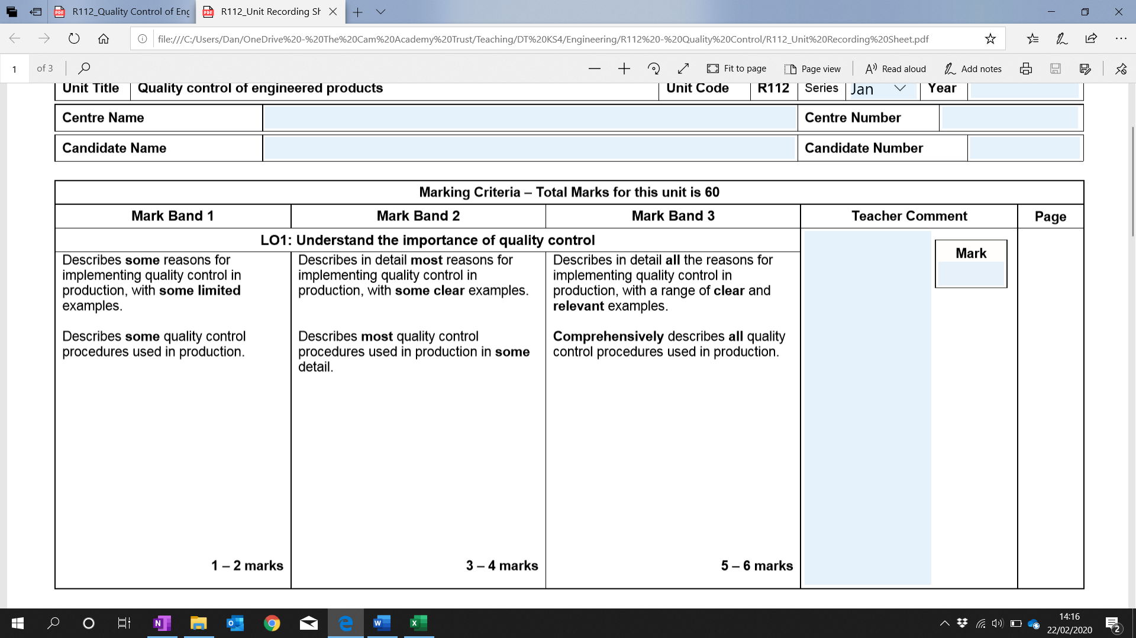

Task 2: Reading a Micrometer

Image result for drill bitTask 2: Measurement Checking Tools

|  |  |  |  |
| --- | --- | --- | --- |
| **Tool** | **What does it check?** | **Examples use**  **(see list of items below)** | **Results** |
| **Digital calipers** |  |  |  |
| **Outside calipers** |  |  |  |
| **Inside calipers** |  |  |  |
| **Micrometer** |  |  |  |
| **Feeler gauges** |  |  |  |

## **Example Item list**

* Image result for mild steel flat barTwist Drill Bits
* Stock Flat Bar Mild Steel
* 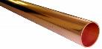Image result for aluminium round barAluminium bar
* Image result for tipex lidCopper pipe
* 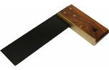Plastic lid
* Paper
* Try square

Task 2  
Assessment of product quality through inspection and quality control techniques

The company has asked you to create the set of Quality Control steps for manufacturing the G-Clamp. It will be used to check all elements of quality of the G-Clamp before it is packaged and sent out.

You will plan the Quality Control Procedure. Then you will carry it out on real G-Clamps, and evaluate the process.

Your tasks:

1. **Describe all QC techniques and inspection checks for manufacturing**  
   Example to include:
   * Micrometres, Gauges, Comparators, Jigs/ Fixtures, X-rays, Ultrasonic (non-destructive) crack testing, Visual inspections
   * Importance and relevance of tolerances
   * Corrective actions
   * Sampling techniques
2. **Plan your quality Control Procedure**Select from above the steps for checking the quality of the G-Clamp.  
   Create a table of checks:
   * List of checks: list all the things that should be checked on the product
   * Explain what you’re checking for and why it’s important
   * Name (and picture of?) the tools/equipment you’ll use to perform each check
   * Describe how you’ll perform the check, using the tools/equipment
   * Include tolerance limits – what is going to be your acceptable (tolerated) range
3. **Carry out your Quality Control Procedure**

Complete each step. Include for each step the following:

* Photo of you carrying out the step
* Advantage of doing it that way
* Disadvantage you found of doing it that way
* Conclusion. For example:
  + would you use this tool / method? Why / Why not?
  + How long did it take? Would it suit scaled up production?

1. **Review your Quality Control Procedure**
   * Review could include
     1. How I did the visual checks, comparing to drawing. Effectiveness. Importance
     2. Tolerances – why it’s important to set these.
     3. Cycle time and arrangement of workers/machinery to increase speed
     4. Consistency and batch checking
   * Table of results from QC checks on G-Clamp
     1. Transportation – reducing waste

Task 3: Report:  
Modern Technologies in QC

|  |  |  |  |
| --- | --- | --- | --- |
| **Modern quality control technology** | **What it is...** | **What benefit does it bring?** | **Example(s) of this in production** |
| Non-destructive Testing |  |  |  |
| X-ray crack testing |  |  |  |
| 3D scanning |  |  |  |
| CNC measurement checks |  |  |  |
| Use of robotics |  |  |  |
| Application within Computer Integrated Engineering (CIE)/ Computer |  |  |  |
| Automated inspection/rejection |  |  |  |

Task 4: Report:  
Lean Manufacturing and Waste Management

**Causes of Waste in Manufacturing**

|  |  |  |  |
| --- | --- | --- | --- |
| **Cause of waste in manufacturing** | **What it is...** | **Impact on Production** | **Example(s)** |
| Time |  |  |  |
| Materials |  |  |  |
| Resources |  |  |  |
| Processes |  |  |  |
| Supply |  |  |  |
| Space |  |  |  |

**Categories of Waste**

|  |  |  |  |
| --- | --- | --- | --- |
| **Categories of Waste** | **What it is...** | **Impact on Production** | **Example(s)** |
| Transportation |  |  |  |
| Inventory |  |  |  |
| Movement |  |  |  |
| Waiting |  |  |  |
| Over-Processing |  |  |  |
| Over-Production |  |  |  |
| Defects |  |  |  |

**Methods of Reducing Waste – Design for Manufacturing Assembly**

|  |  |  |  |
| --- | --- | --- | --- |
| **Design for Manufacturing Assembly** | **What is is...** | **Impact on Production** | **Example(s)** |
| Common fixing strategy |  |  |  |
| Standardised Components |  |  |  |
| Complexity reduction |  |  |  |
| Make versus buy |  |  |  |
| Handling and processes |  |  |  |

**Methods of Reducing Waste – Sustainable Design**

|  |  |  |  |
| --- | --- | --- | --- |
| **Sustainable Design** | **What is is...** | **Impact on Production** | **Example(s)** |
| Material reduction |  |  |  |
| Life Cycle Analysis |  |  |  |
| End-of-life disposal |  |  |  |
| Recycled Materials |  |  |  |